Lea’s modeling RMS guesses Jan 3 2025

STORAGE: When each item is studied it has Content features F, Unchanging context features XU and Changing context features XCjk, where j is the list number and k is the item number within list, where j = 1, …,10 and k = 1,….,20. These are stored in a trace with the same parameters u, c, g. (we could define study context for j list XSj here)

RETRIEVAL:

**STAGE 1**: XU + XCjk are used to probe memory with the REM rules, producing for each trace in the entire study to that moment a likelihood ratio XRjk. There is a first stage threshold for activation XT. Traces with XR > XT are activated and sent to stage 2.

Note1 : It is possible the first stage probe uses only XCjk features. The planned new experiment may foster such a probe.

Note 2: If needed for something, it is possible to let XT change with list number and be termed XTj.

**STAGE 2**: The F features are used to probe the activated traces, producing REM Odds. An old response is given if Odds> 1, although some conditions may require a different odds than 1.

**CONTEXT CHANGES**:

1. XUjk increases with k. One way: Let wi decrease from w1 to w20=0 where wi is the probability of replacing each XCjk value by a random value from the geometric with parameter g. This explains the within list improvement in the XC as testing continues.
2. The XCj20 change each time j increases by 1 (i.e. changes between lists). One way: To produce the next XCj20, each XUj20 current value is replaced with probability z by a random value based on sampling from the geometric with parameter g. This changes systematically the XC context features as lists continue, so that traces from previous lists tend not to be activated in stage 1, the older are those previous lists.

**TESTING EFFECTS**: There is a stage 2 threshold FR.

1. If an activated trace likelihood is < FR a new trace is stored based on the current F, XC and XU values.
2. If an activated trace likelihood is greater than XR than the trace is strengthened, and no new trace is stored. STRENGTHENING: Each F feature in the trace that does not match the test F feature is replaced by the test value with probability S.
   1. Note: We could also strengthen the XC features, but there could be a problem because the current XC features at the start of the lists are bad ones.

Criterion changes: from test position 1-20, content odds criterion gradually decrease from 1-20, producing the merging effect of targets and foil, not having the criterion change also have merging prediction, but having criterion change makes that merges more (see below)

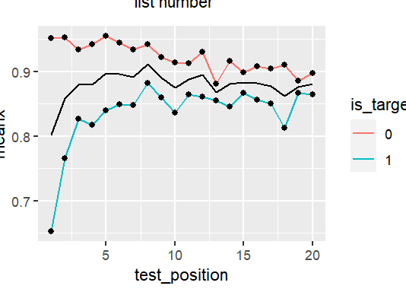

FINAL TESTING:

**STAGE 1**: The probe XU and XC features start with a change from the most recent list and recent item XU and XC features: XC(10)(20) is changed to XCF1 and XU is changed to XUF using a probability X, where XCFi is the final test position; XUF does not change further doing final testing. All prior traces at each point in final testing are activated if and only they pass a threshold. Should this threshold be XT? Might try this first.

Note: We might need XCFi to drop as i increases, in order to produce enough output interference. But first do not add this.

**STAGE 2**: All activated traces, initial and final thus far, produce likelihoods according to REM with its three parameters. An old response is given if the ODDS > 1 (although this criterion may need to change as testing continues if, for example, CRs remain flat).

**TESTING EFFECTS**: Storing a new test trace occur sif the trace likelihood ratio is less then V. If greater than V we strengthen the FF features using the same S probability as during initial testing.

[Context Reconstruction: This is not part of this model, but if there were a long delay until final testing then it is possible the context features in the traces passing threshold are used to improve the context features in the probe, one method consistent with Bauml’s results.]

*Lea: How close is the above model description to what you are trying?*

*Lea: To understand the peculiar results you have been obtaining in final testing, much simpler version of this modeling should be tried one at a time.*

*study context ------------------------- test context*

Item1list1[1,1,1] Item2list1[1,1,1] …………p_drift……….PL1[1,2,3] , [1,2,1], [1,1,1]

p_list

Item1list2[1,2,2] item2list2[1,2,2].....................

p_drift drops from list to list

p_list keep constant